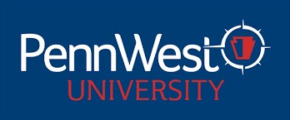

PENNSYLVANIA WESTERN UNIVERSITY
UNIVERSITY-WIDE CONTRACTUAL COMMITTEES
2025-2026 ACADEMIC YEAR

PROMOTION COMMITTEE 2025-2026 AY

California Representatives
John Staszel EAH/Visual & Performing Arts 2027
Ghassan Al-Sinbol STB/Computing & Engineering Technology 2027

Clarion Representatives
Laurie Pierce HS&HS/Nursing & Health Professions 2027
Natasha Dias STB/Biology Earth & Environmental Sciences 2027

Edinboro Representatives
Molly Wolf HS&HS/Social Work Sociology & Human Services 2027
Ruth Stauffer (ED) HS&HS/Exercise, Health & Sport Sciences 2027

College of Education, Arts & Humanities
VACANT 2026

College of Health Sciences & Human Services
Everett Painter (ED) Psychology, Counseling & Art Therapy 2026

College of Science, Technology & Business
Bismark Oduro (CAL) Chemistry, Mathematics & Physics 2026

Non-teaching Faculty Representative
Mary Buchanan (CL) University Libraries 2026

