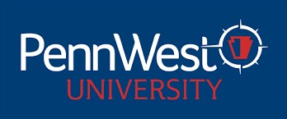

PENNSYLVANIA WESTERN UNIVERSITY
UNIVERSITY-WIDE CONTRACTUAL COMMITTEES
2025-2026 ACADEMIC YEAR
SABBATICAL COMMITTEE 2025 – 2026 AY

College of Education, Arts, & Humanities
Jennifer Boyer (CL) Criminal Justice, History & Politics/Criminal Justice 2026
Mary Nientimp (ED) Education/Special Education 2026

College of Health Sciences & Human Services
Nicole Evanick (CAL) Nursing & Health Professions/Nursing 2026
Joyce Jagielo (ED) Psychology, Counseling & Art Therapy/Psychology 2026

College of Science, Technology, & Business
Nan Li (CAL) Business, Economics & Communication/Finance 2026
Jingze Jiang (ED) Business, Economics & Communication/Economics 2026

Non-Teaching Representative
Andrea Wyman (ED) University Libraries 2026

Campus Representatives
Clarion
Briana Steele Counseling 2027
Alawya Alawami STB/Computing & Engineering Technology/Applied Comp 2027

California
Pratibha Menon STB/Computing & Engineering Technology/CIS 2027
Laura DeFazio EAH/Visual & Performing Arts/Visual Art 2027

Edinboro
Douglas Puharic STB/Chemistry Math & Physics/Math 2027
Mark Sanko EAH/Criminal Justice History & Politics/History 2027

