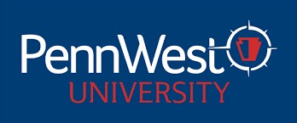

PENNSYLVANIA WESTERN UNIVERSITY
UNIVERSITY-WIDE CONTRACTUAL COMMITTEES
2025-2026 ACADEMIC YEAR

TENURE COMMITTEE 2025-2026 AY

California Campus
Keat Murray EAH/ English, Philosophy & Modern Languages 2026
Brenton Wilburn STB/Computing & Engineering Technology 2026
Lindsay Hammond HS&HS/Exercise, Health, & Sport Sciences 2026

Clarion Campus
Marcella McConnell EAH/Math Ed 2026
Jennifer May HS&HS/Social Work, Sociology & Human Services 2026
Rachel Newbury Non-Teaching/University Libraries 2026

Edinboro Campus
Nathan Fralick Non-Teaching/University Libraries 2026
Joyce Jagielo HS&HS/Psychology, Counseling & Art Therapy 2026
Kevin Courtright EAH/Criminal Justice, History & Politics 2026

